PROJECT REPORT

ON

Result Generator

Submitted By

Aakash M. Gupta (01)

Brijesh S. Vishwakarma (11)

**Introduction**

A result generator is a Convertor, which converts University MCA result into Excel spreadsheet. In this application the user needs to first select result which user wants to convert and then enter the Seat number and then excel sheet will be generated.

Earlier it was not possible to convert from pdf to excel online. The users had to manually enter data into excel sheet referring the result pdf. Using this system any user can directly convert a result pdf into excel sheet in a proper format and indentation in a single click.

**Objective of the project:**

The purpose of this system is to reduce the time and work of the administrator or the teacher or the user who manually used to enter the data in an excel sheet.

**Scope of the project:**

The aim of the project is to provide the user with the interface where the user can select from a drop-down list the university result pdf to convert into spreadsheet. The system would allow the user to upload his/her university result pdf and then convert it into excel sheet.

**Existing System:**

There is no system that converts result pdf to excel. User or teacher had to manually enter data in proper format.

**Proposed system:**

* Helps the user to automatically convert from result generator.
* Reduces the work time of the user.
* Provides proper format and indentation after conversion.

**How pdf to excel generator works:**

* A welcome page will be shown to the user.
* The page consists of a drop down menu in which the user can select which University MCA result to convert into excel.
* The user can set the range of students to be displayed based on seat numbers and convert only those student's data if the user desires to do so.

**Technology Stack:**

* Programming language used: ASP.NET with C# (vs 2012)
* Hardware Requirements:

512 MB disk space, Windows OS

* Software used:

Microsoft Visual Studio 2012, MS Excel

**Characteristics of proposed system:**

* The proposed system is user friendly because the conversion of pdf to excel is fast and the data is maintained efficiently with proper indentation.
* Moreover, the Graphical User Interface of the system helps the user to deal with the system very easily.
* The proposed system saves time. All the data from result pdf is fetched into excel sheet immediately.
* Moreover, work becomes simpler because the user no longer needs to enter data manually into an excel sheet.

**Screen Short:**

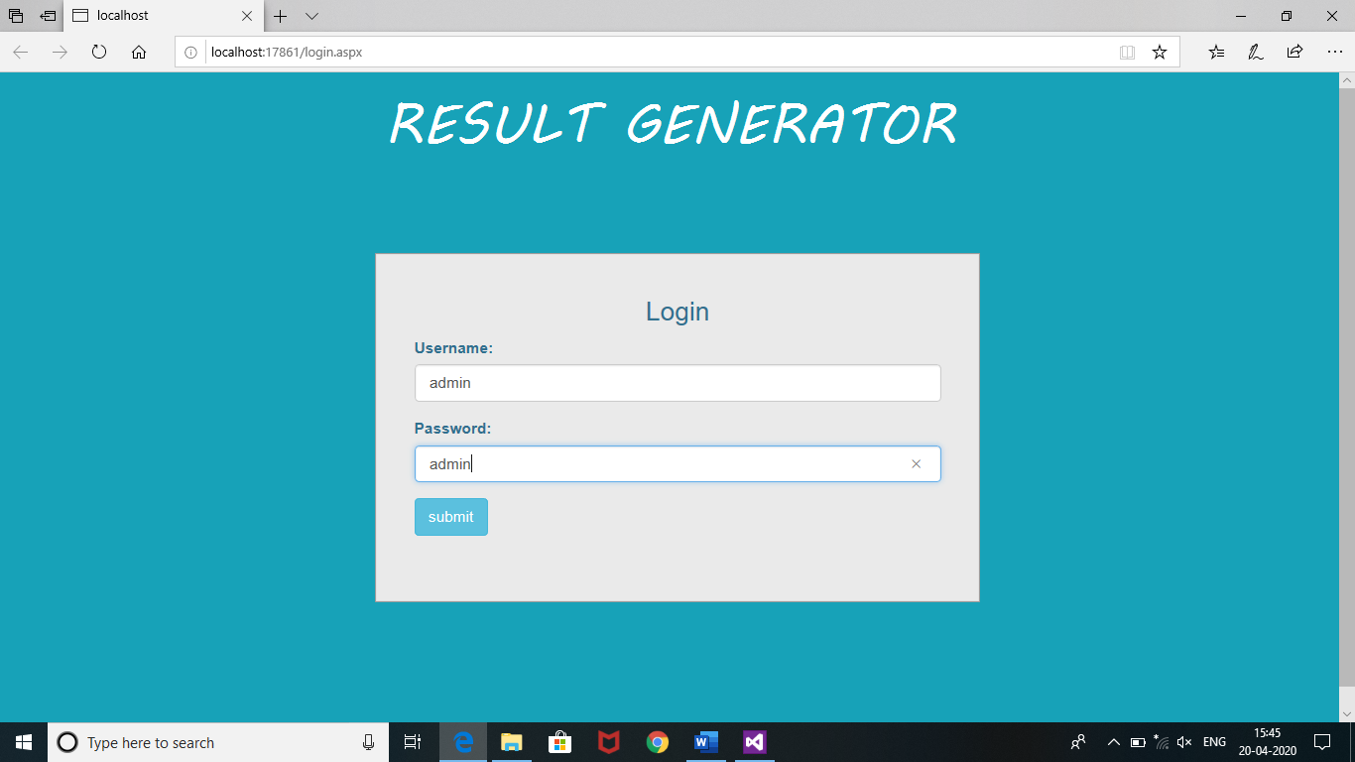



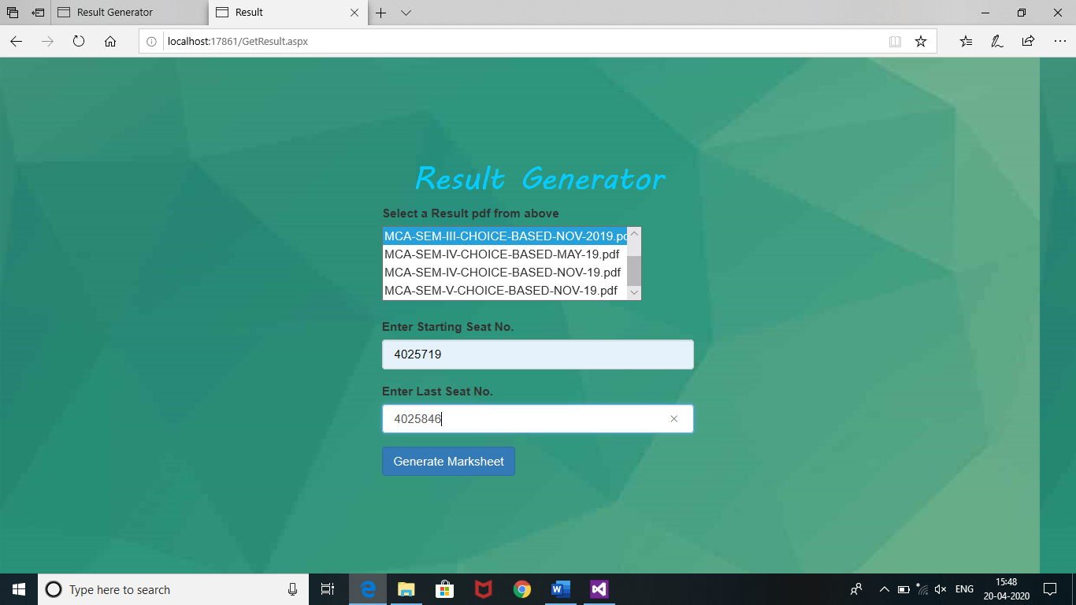

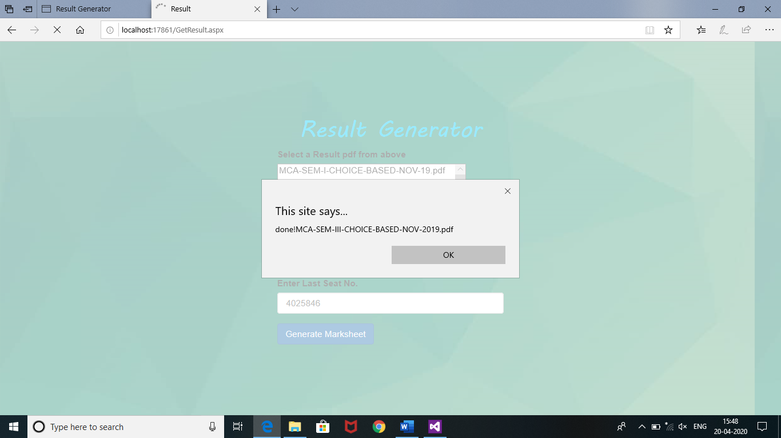

**Result:**

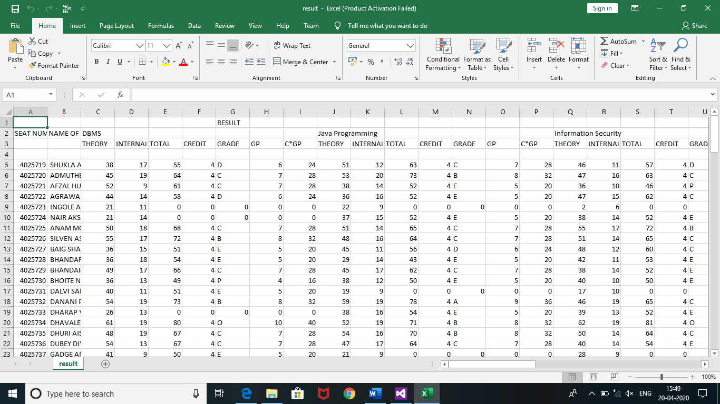

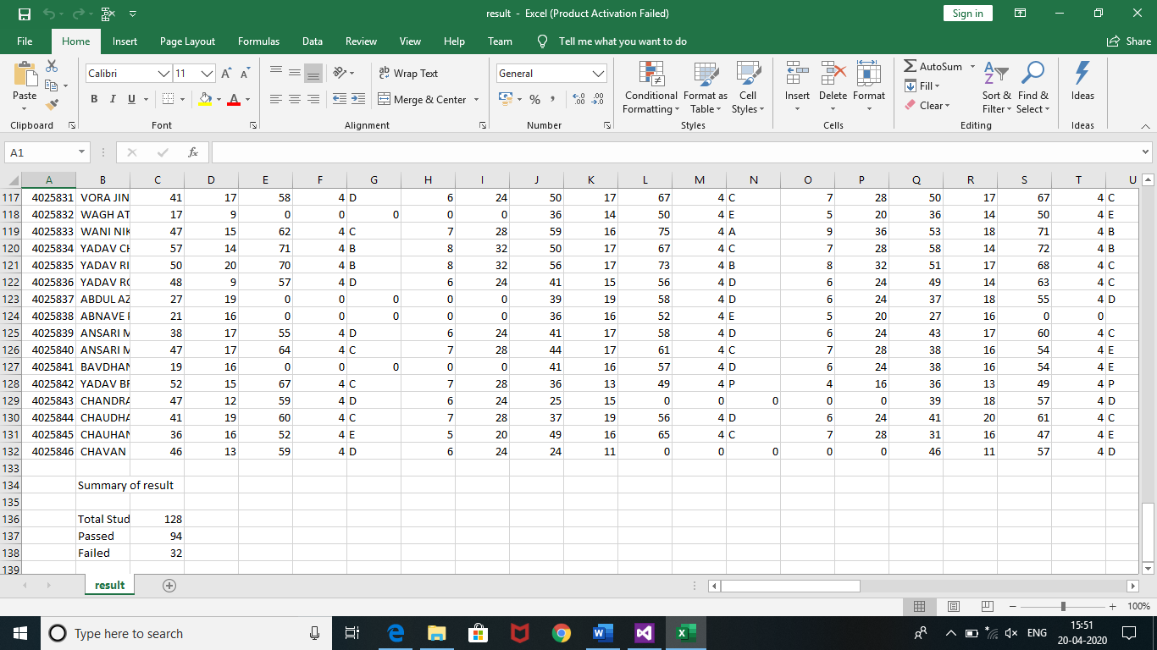

**Conclusion:**

The project has been completed and is working fine as per the requirement of the staff.

**Bibliography:**

1. Stackflow.com
2. javaTpoint
3. Microsoft.visualstudio.com